Explainable Fraud Investigation Using Graph Neural Networks
Author Name(s), Department / Institution
Email address(es) — to be completed
Abstract—Financial fraud investigation increasingly requires systems that can examine relationships among transactions while providing evidence that analysts can inspect. Conventional feature-based classifiers can identify suspicious records but may offer limited visibility into relational patterns and the basis of individual predictions. This paper proposes TRACE-X, an investigation-oriented framework that combines graph neural network (GNN) prediction with post-hoc graph explanations and an interactive evidence view. The initial implementation is planned around the Elliptic Bitcoin transaction dataset, in which transactions are represented as nodes and directed fund-flow relationships as edges. A GraphSAGE model is proposed as the primary graph-learning baseline, while GNNExplainer is considered for identifying prediction-relevant subgraphs and features. The evaluation will compare graph learning with non-graph baselines and assess detection performance, explanation faithfulness, and explanation stability using a time-aware split where feasible. At this stage, the contribution is a proposed architecture and evaluation protocol; no experimental performance claims are made. The intended outcome is a transparent investigation workflow in which model scores are treated as risk indicators and final decisions remain subject to human review.
Index Terms—Financial fraud detection, graph neural networks, explainable artificial intelligence, GraphSAGE, GNNExplainer, transaction networks, financial forensics.

I. INTRODUCTION
Financial fraud is difficult to investigate because suspicious activity may be distributed across multiple transactions and connected entities. A transfer that appears ordinary in isolation can form part of a larger pattern when its upstream and downstream relationships are considered. Many established detection pipelines rely on engineered transaction features, rules, or conventional classifiers. These methods remain useful, but they may not directly model the structure of a transaction network, and a high-risk score alone does not necessarily tell an investigator which relationships deserve attention.
Graph neural networks learn representations by aggregating information from connected nodes. This makes them a promising approach for transaction graphs, where nodes may represent transactions or accounts and edges encode transfers or other relations. However, relational learning introduces its own interpretability challenge: the model's prediction can depend on a combination of node features and graph structure. An investigation system therefore needs to expose evidence associated with a prediction rather than present the score as an unquestionable conclusion.
This work proposes TRACE-X, a prototype framework for explainable fraud investigation. The framework links transaction data preparation, graph construction, GNN-based risk prediction, post-hoc explanation, and an interactive evidence interface. The initial study uses the Elliptic Bitcoin transaction graph as a reproducible public benchmark. In this dataset, a node denotes a Bitcoin transaction and a directed edge denotes a flow relationship between transactions; consequently, the initial prediction task is transaction-level illicit-activity classification rather than bank-account fraud classification [1].
The work is guided by three questions: (1) how does a graph-based model compare with conventional classifiers under a consistent evaluation protocol? (2) can a post-hoc explanation identify compact graph evidence associated with a selected prediction? and (3) how stable and useful is that evidence under controlled perturbations? The proposed contributions are: a modular detection-to-investigation architecture; an explanation workflow that presents relevant graph structure and features; and an evaluation protocol that considers both detection and explanation quality. These are intended contributions to be tested, not completed experimental findings.

II. RELATED WORK
Graph-based financial fraud detection has developed around the observation that financial activity is relational. Weber et al. introduced the Elliptic dataset and evaluated logistic regression, random forests, multilayer perceptrons, and graph convolutional networks for illicit Bitcoin transaction detection [1]. Their results also caution against assuming that a graph model will automatically outperform a strong tabular baseline. This motivates direct and reproducible baseline comparison in the present study.
GraphSAGE learns node representations by sampling and aggregating features from local neighborhoods, allowing inductive representation learning rather than requiring a separate learned embedding for every node [2]. Its neighborhood aggregation mechanism is appropriate for an initial prototype because it provides a well-established GNN baseline and can be adapted to graphs with changing node sets. Model selection will nevertheless depend on the dataset representation, label availability, and computational constraints.
GNNExplainer is a model-agnostic post-hoc method that searches for a compact subgraph and a subset of features relevant to a GNN prediction [3]. Such outputs can be rendered as highlighted nodes, edges, and feature summaries. An explanation should not be interpreted as a causal proof of fraud: it indicates evidence associated with the model's output under the explanation method's assumptions. Its faithfulness and stability need to be evaluated rather than inferred from a visually convincing graph.
A systematic review by Motie and Raahemi surveys GNN methods in financial fraud detection and identifies methodological choices across graph types, tasks, and learning strategies [4]. This broader literature suggests that the research question must be narrower than simply combining GNNs and explainability. TRACE-X therefore emphasizes the investigation workflow and the evaluation of explanation evidence alongside predictive performance. A detailed literature search is still required before claiming a novel research gap or finalizing the conference submission.

III. PROBLEM FORMULATION
Let the transaction network be represented by a directed attributed graph G = (V, E, X, T), where V is the set of transaction nodes, E is the set of directed fund-flow relationships, X contains node attributes, and T denotes temporal information when available. For each labelled node v_i, the learning task predicts y_i ∈ {licit, illicit}. Unlabelled transactions are retained only where the chosen training protocol permits their use without leaking test labels or future information.
A graph model f_θ receives the graph structure and features and outputs a probability p_i = f_θ(G, X)_i for the illicit class. A decision threshold τ can convert p_i into a review flag, but τ must be selected on validation data and interpreted in light of class imbalance and the cost of false negatives and false positives. The output is a risk signal, not a legal or factual determination that a transaction is criminal.
For a selected node v_i, an explanation method produces an explanatory subgraph S_i ⊆ G and a relevant feature set F_i. The investigation interface should show the prediction, the highlighted graph evidence, relevant features, and the explanation method used. The user interface must distinguish model output from explanation and from any later human investigation finding.

IV. PROPOSED METHODOLOGY

A. Dataset and Preprocessing
The initial benchmark is the Elliptic Bitcoin transaction dataset described by Weber et al. [1]. The original release contains approximately 203,000 transaction nodes, approximately 234,000 directed edges, 166 node features, and 49 temporal steps; labels include licit, illicit, and unknown. Exact counts will be confirmed from the downloaded files and preprocessing script before the final paper is submitted. The dataset concerns cryptocurrency transactions, so conclusions will be limited to this domain and will not be presented as direct validation on conventional bank transfers.
Preprocessing will align transaction identifiers across feature, label, and edge files; remove malformed references; document missing values; and preserve the graph's directed and temporal structure where supported. The primary split should respect time, using earlier steps for training, a subsequent period for validation, and later steps for testing. This reduces the risk that evaluation unrealistically benefits from future information. Any alternative random split will be reported separately and justified. Unknown labels will not be treated as negative labels.

B. Detection Model
GraphSAGE is proposed as the first GNN model. At each layer, the model aggregates representations from sampled neighboring nodes and combines the aggregated information with the node's current representation. A final prediction head maps the learned representation to an illicit-transaction probability. Training will use only permitted labelled training nodes, with class weighting or another imbalance-aware strategy selected on the training data. Hyperparameters will be selected using validation data, and random seeds and software versions will be recorded for reproducibility.
Two non-graph baselines are proposed: logistic regression and random forest trained on the same eligible node features. Where practical, a multilayer perceptron may be included as an additional feature-only baseline. All models must use comparable temporal splits and avoid feature or label leakage. Because the benchmark is imbalanced, the primary metrics will include precision, recall, F1-score, and area under the precision–recall curve (PR-AUC), alongside confusion matrices and threshold-specific results. Accuracy alone will not be treated as sufficient.

C. Explainability and Investigation View
GNNExplainer will be evaluated as the initial post-hoc explanation method [3]. For each selected prediction, it will produce a candidate explanatory subgraph and relevant feature subset. The frontend will display the target transaction, highlighted neighboring transactions, connecting edges, the model score, and a concise evidence summary. The summary will be generated from observable model and graph outputs; it will not invent motives or assert that a transaction is definitively fraudulent.
Explanation quality will be assessed using perturbation-based faithfulness tests: removing or masking explanation-selected elements should be compared with removing matched non-explanation elements, while observing the change in model output. Stability will be studied by applying controlled perturbations or repeated explanation runs and measuring overlap between selected edges or features. These tests require careful controls because graph perturbations can create unrealistic inputs. A small analyst-oriented usability assessment may be considered later, subject to access to participants and an appropriate protocol.

V. SYSTEM ARCHITECTURE AND PROTOTYPE
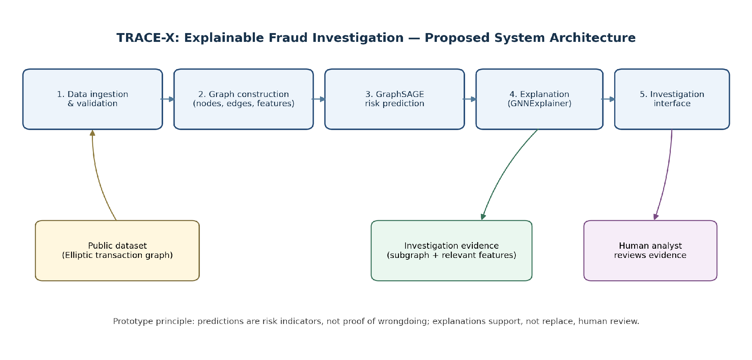
Fig. 1. Proposed TRACE-X architecture. Model predictions and explanation outputs are presented as investigation evidence for human review.
The system is organized into five services. First, the ingestion layer validates the public dataset and records preprocessing metadata. Second, graph construction produces aligned node features, directed edges, labels, and temporal indices. Third, the GraphSAGE service returns risk scores for eligible nodes. Fourth, the explanation service generates a local explanation for a selected prediction. Fifth, the investigation interface visualizes the graph and associated evidence. A React-based frontend and a Python API are proposed for the implementation; these are design choices and should be updated if the deployed prototype uses a different stack.
For the initial client review, the interface may use clearly labelled sample data to demonstrate node selection, graph highlighting, risk details, and the explanation panel. Until the model is trained and connected, scores and explanation content must be identified as illustrative. The prototype should not describe a sample graph as a live inference result. This separation allows the frontend to be demonstrated without overstating implementation progress.

VI. EXPERIMENTAL PLAN AND EXPECTED OUTPUT
Experiments will compare GraphSAGE against logistic regression and random forest using the same temporal evaluation protocol. Reported detection results will include PR-AUC, precision, recall, F1-score, and confusion matrices. The study will report class distributions for each split, threshold-selection procedures, training configuration, and runtime where measurable. Confidence intervals or repeated runs should be included where computationally feasible.
The explanation evaluation will examine whether highlighted subgraphs and features are associated with changes in the prediction under controlled perturbations, and whether the explanations remain reasonably stable under small, justified changes to the input. The investigation interface will be evaluated separately from the model, since visual clarity does not establish predictive or explanation quality. No numerical result is reported in this initial manuscript because model training and evaluation have not yet been completed.
Expected outputs are a reproducible transaction-graph pipeline, a baseline comparison, local explanation examples, and an interactive prototype. The work's value will depend on the measured results and on whether the investigation-oriented explanation workflow adds useful evidence beyond a fraud score. If the experiments do not show a predictive improvement for GraphSAGE, that result will be reported transparently; the system may still be useful as an explanation and investigation interface, but that utility must be evaluated separately.

VII. LIMITATIONS AND ETHICAL CONSIDERATIONS
The Elliptic dataset is cryptocurrency-specific and does not represent all banking or payment systems. Labels are incomplete, and the graph and features are partly anonymized. Temporal splitting and strict feature handling are necessary to reduce leakage. Explanation methods can be unstable or misleading, and a highlighted subgraph is not proof of causation. High-risk outputs should support prioritization for review rather than automatic punitive action. Any future use on real financial records would require lawful access, data minimization, security controls, auditability, and appropriate human oversight.

VIII. CONCLUSION
This paper has presented TRACE-X, a proposed framework for explainable fraud investigation using graph neural networks. It combines transaction graph construction, GraphSAGE-based prediction, post-hoc graph explanations, and an evidence-centered interface. The planned evaluation compares graph and feature-only baselines while testing explanation faithfulness and stability. The current manuscript defines the architecture and experimental plan; it does not claim completed implementation or measured performance. The next steps are to implement the data pipeline, train and evaluate the models, connect actual explanation outputs to the interface, and refine the research contribution through a more comprehensive literature review.

REFERENCES
[1] M. Weber, G. Domeniconi, J. Chen, D. K. I. Weidele, C. Bellei, T. Robinson, and C. E. Leiserson, “Anti-money laundering in bitcoin: Experimenting with graph convolutional networks for financial forensics,” in Proc. ACM SIGKDD Workshop on Anomaly Detection in Finance, 2019, pp. 1–8. doi: 10.48550/arXiv.1908.02591.
[2] W. L. Hamilton, R. Ying, and J. Leskovec, “Inductive representation learning on large graphs,” in Advances in Neural Information Processing Systems, vol. 30, 2017.
[3] Z. Ying, D. Bourgeois, J. You, M. Zitnik, and J. Leskovec, “GNNExplainer: Generating explanations for graph neural networks,” in Advances in Neural Information Processing Systems, vol. 32, 2019.
[4] S. Motie and B. Raahemi, “Financial fraud detection using graph neural networks: A systematic review,” Expert Systems with Applications, vol. 240, art. 122156, 2024, doi: 10.1016/j.eswa.2023.122156.

